**Phase 9: Reporting, Dashboards & Security Review**

**Reports (Tabular, Summary, Matrix, Joined):**

- Create a Tabular Report

- Create a Summary Report

- Glance at Matrix Report

- Glance at Joined Report

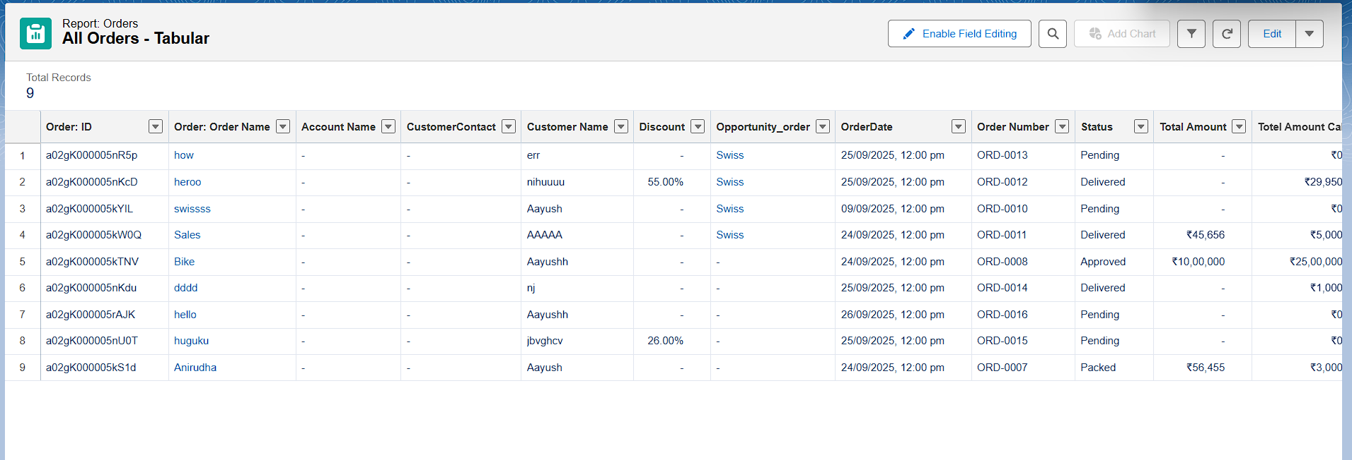

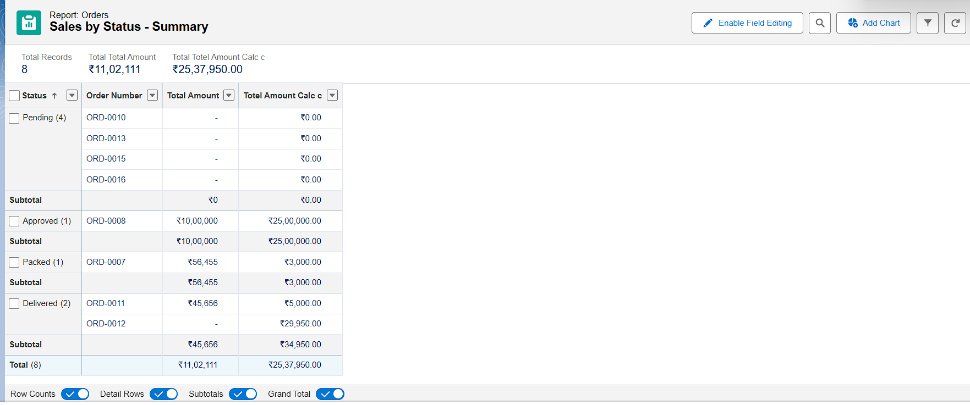

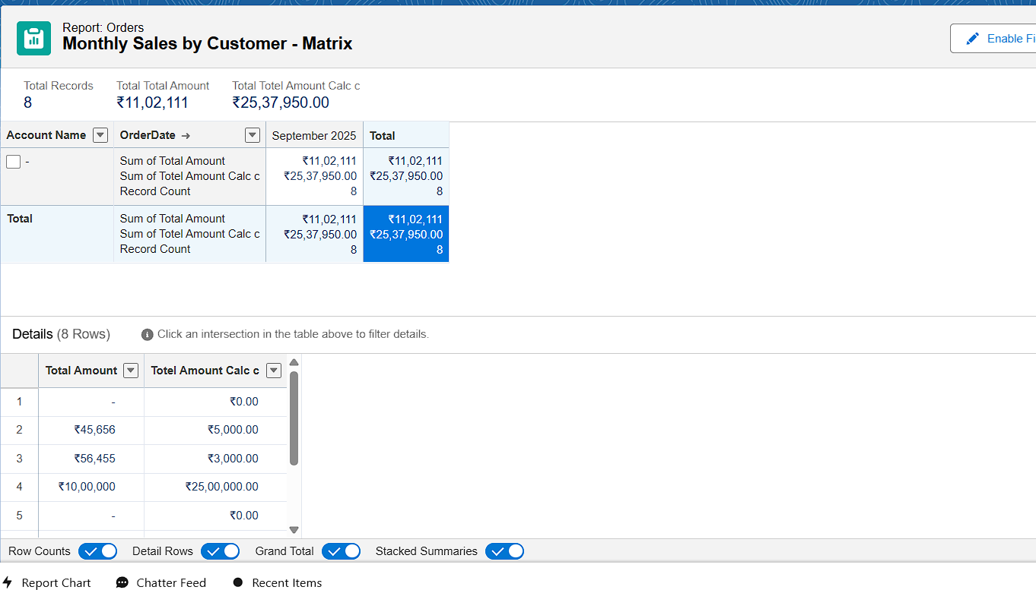

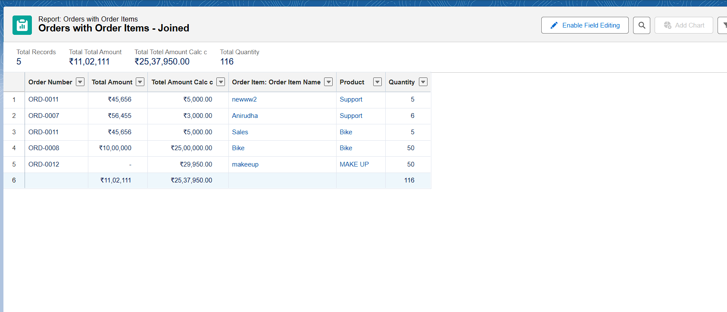

**Report Types:**

**Created Custom Report Type:**

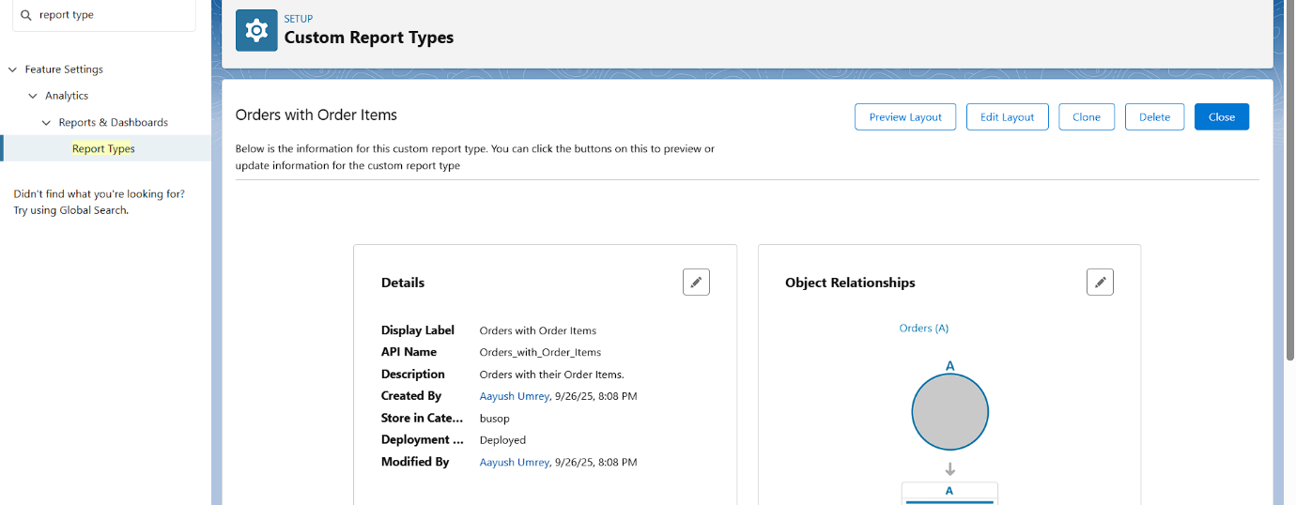

**Dashboards:**

**Created Dashboard:** ‘Order Executive Dashboard'

**Added component:** Pie Chart, Line Chart, Bar Chart, Gauge, Line Table

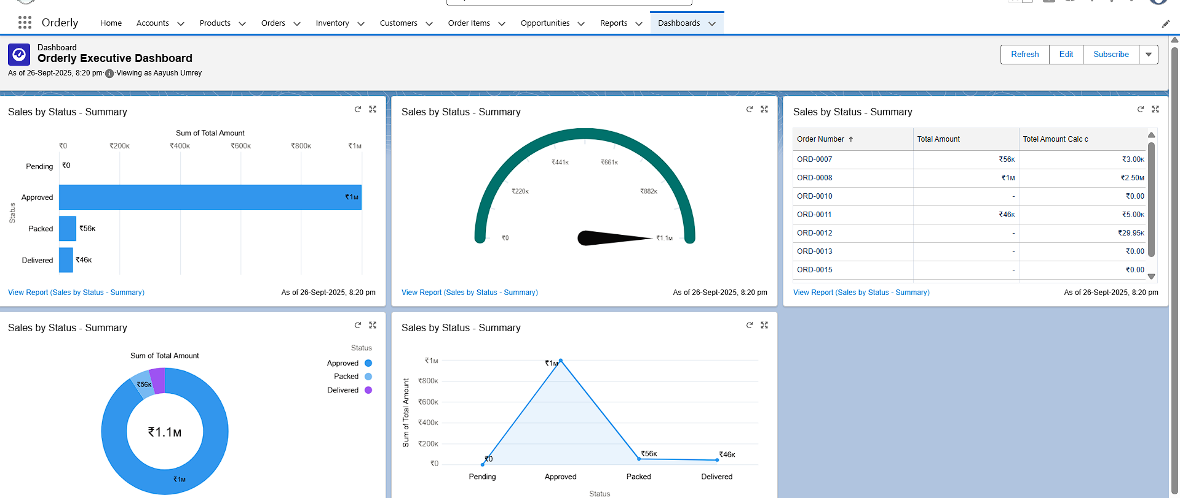

**Dynamic Dashboards:**

- Edited Dashboard → Set 'View Dashboard As' = Logged-in User  
- Confirmed visibility differs by profile/role

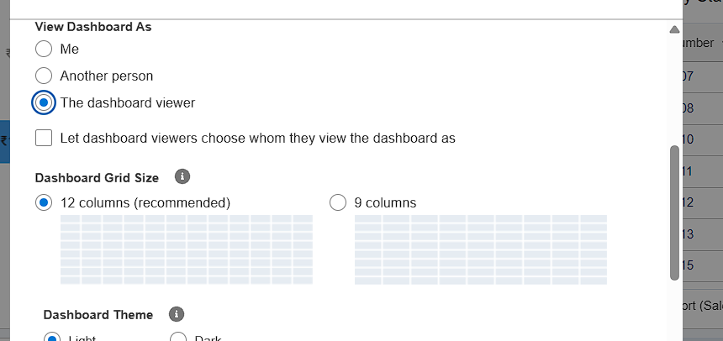

**Sharing Settings:**

**- Reviewed Org-Wide Defaults  
- Updated Accounts access to Public Read Only**

**- Created one Sharing Rule for demo**

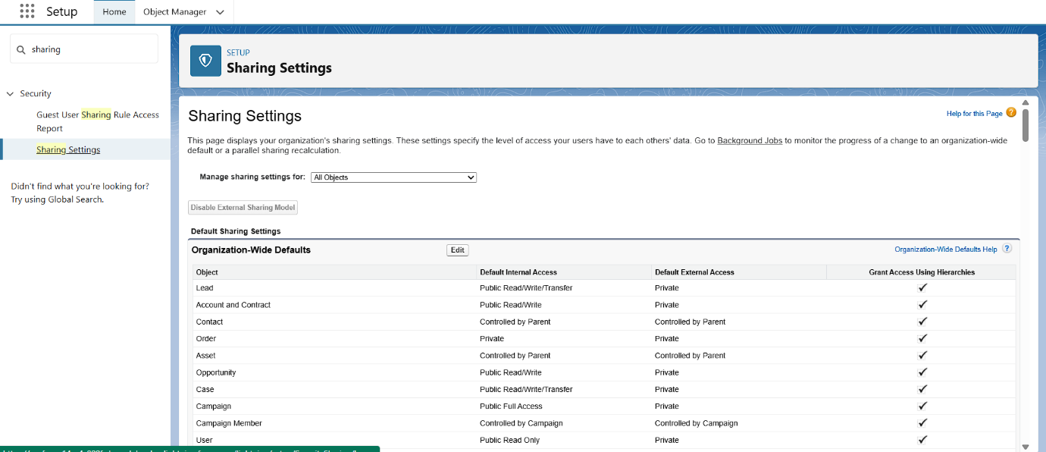

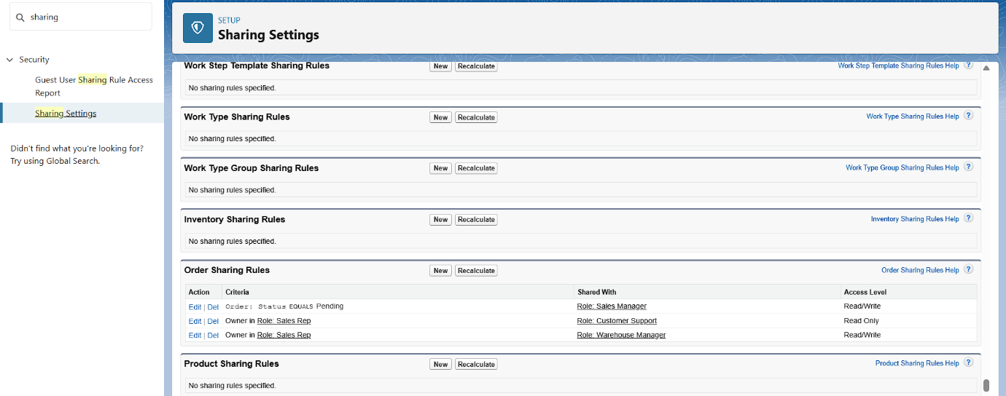

**Field Level Security (FLS):**

- Modified Account → Phone field visibility  
- Hid Phone field for Standard User profile

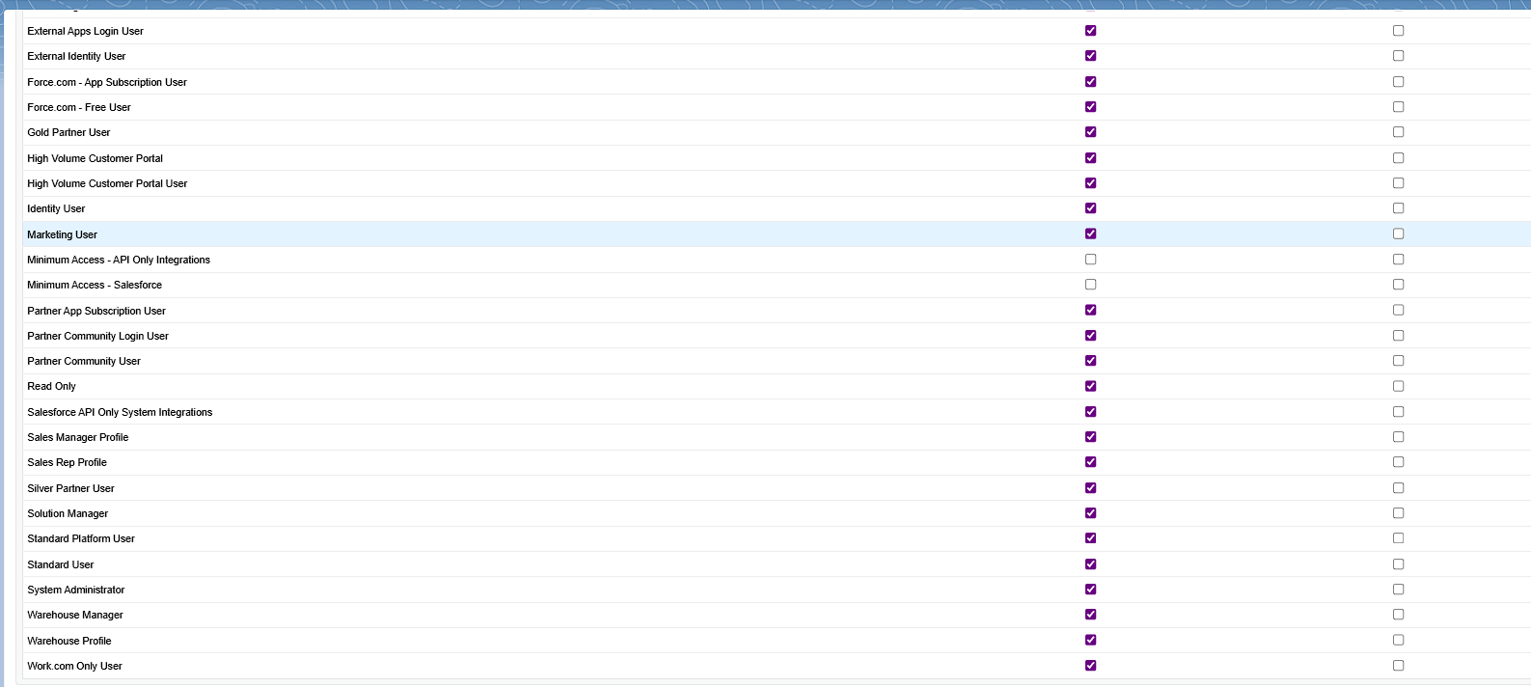



**Session Settings:**

- Reviewed Session Timeout and login policies  
- Changed Session Timeout to 30 minutes

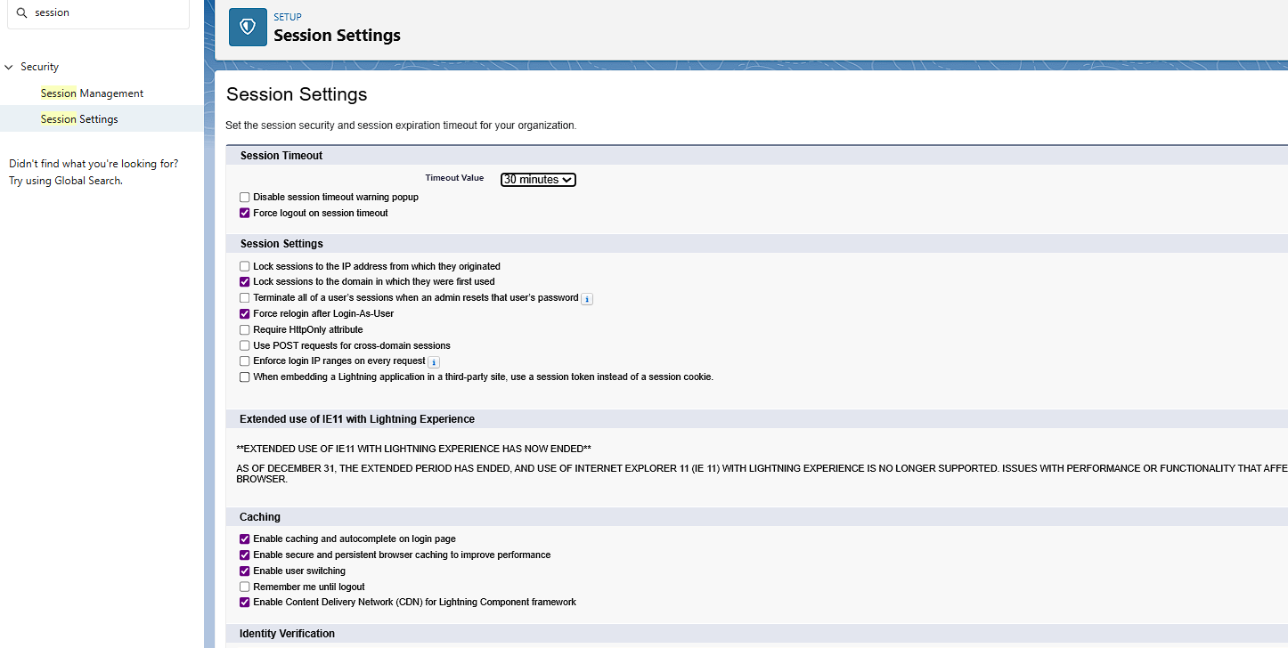

**Login IP Ranges:**

- Added Login IP Range to System Administrator profile  
- Used 0.0.0.0 to 255.255.255.255 for testing

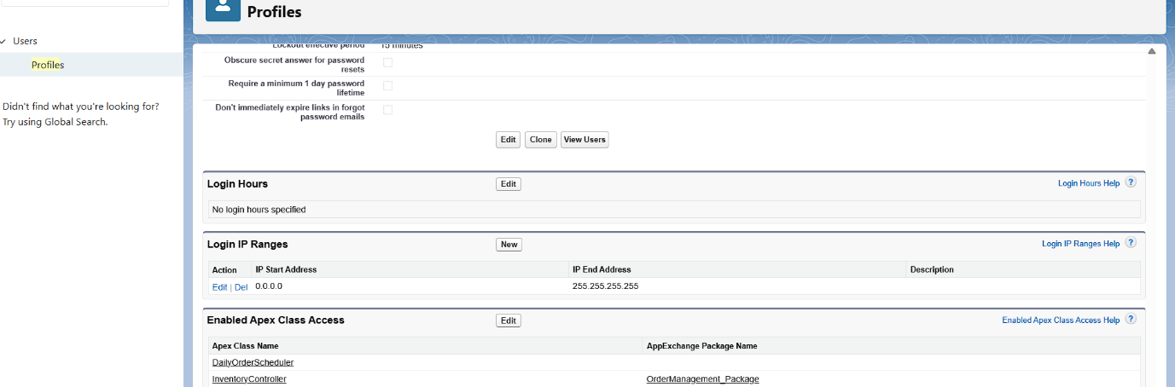

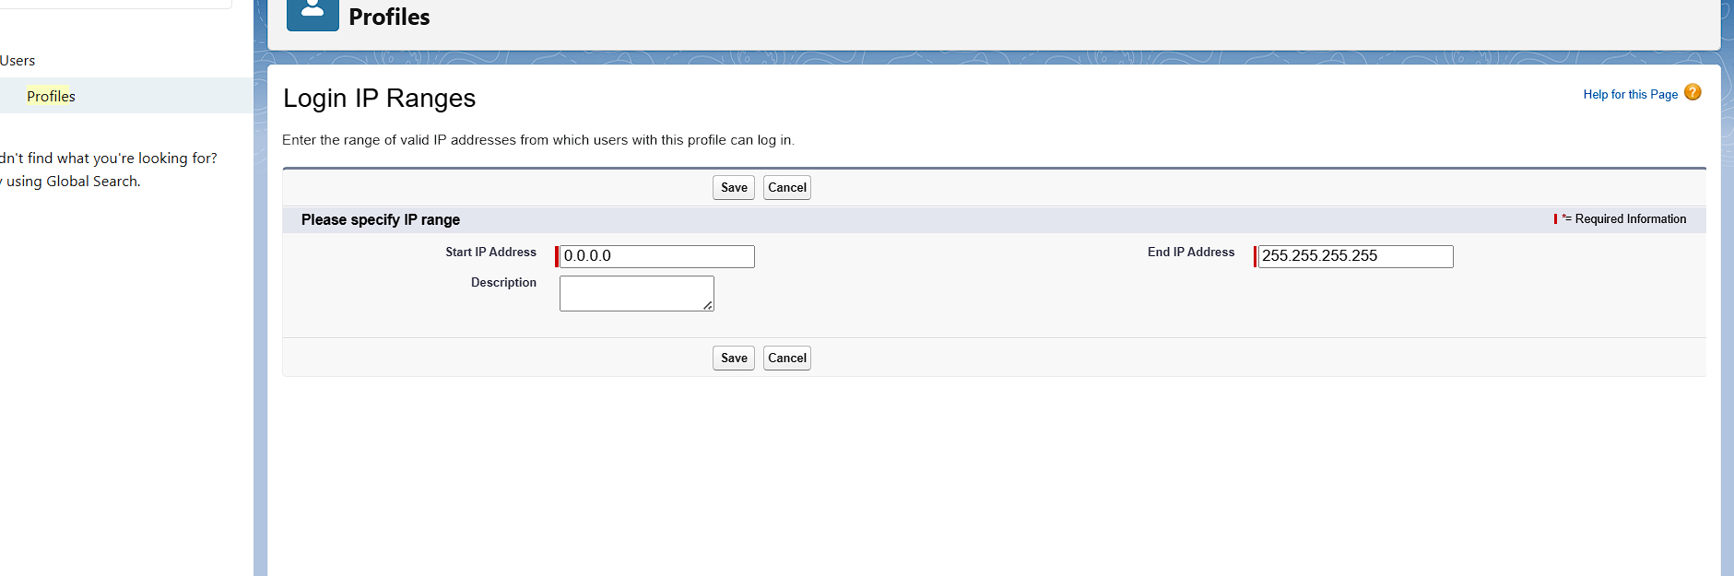

**Audit Trail:**

- Viewed Setup Audit Trail (last 20 changes)  
- Exported full audit history (optional)

